**Is This a Binary Search Tree?**

<https://www.hackerrank.com/challenges/is-binary-search-tree/problem>

For the purposes of this challenge, we define a [binary tree](https://en.wikipedia.org/wiki/Binary_tree) to be a [binary search tree](https://en.wikipedia.org/wiki/Binary_search_tree) with the following ordering requirements:

* The data value of every node in a node's left subtree is *less than* the data value of that node.
* The data value of every node in a node's right subtree is *greater than* the data value of that node.

Given the root node of a binary tree, can you determine if it's also a binary search tree?

Complete the function in your editor below, which has 1 parameter: a pointer to the root of a binary tree. It must return a *boolean* denoting whether or not the binary tree is a binary search tree. You may have to write one or more helper functions to complete this challenge.

**Input Format**

You are not responsible for reading any input from stdin. Hidden code stubs will assemble a binary tree and pass its root node to your function as an argument.

**Constraints**

* *0 <= data <= 104*

**Output Format**

You are not responsible for printing any output to stdout. Your function must return *true* if the tree is a binary search tree; otherwise, it must return *false*. Hidden code stubs will print this result as a *Yes* or *No* answer on a new line.

**Sample Input**

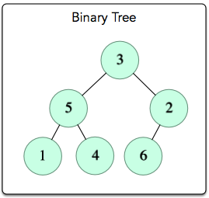

**Sample Output**

No